 | 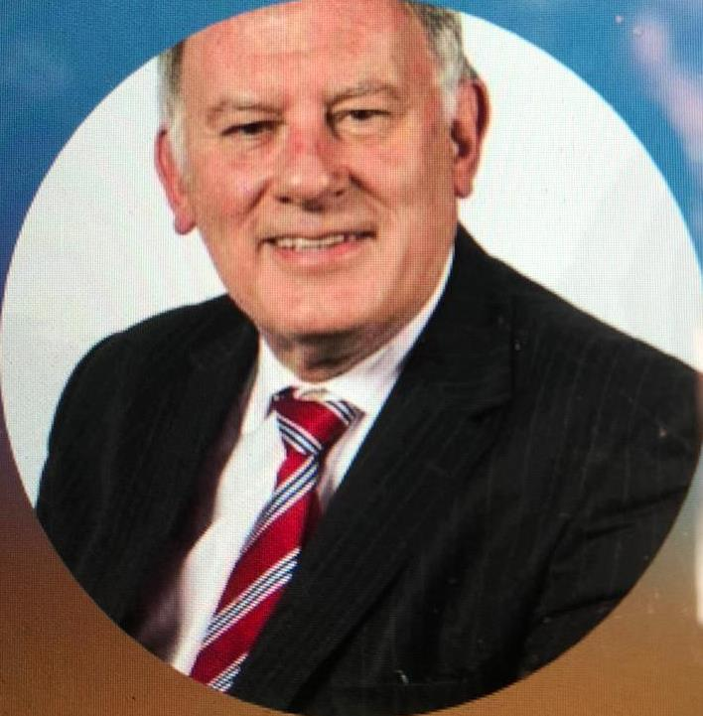  aspose_mlj6bordercell  Contact  London, Surrey GU3 2JL  07918194297  davidbilbe@aol.com  david@baslmediation.com  web site baslmediation.com  Summary  Results-driven litigation chairman and mediator with a proven track record of producing quality outcomes through dynamic listening techniques.  Liaises with clients to determine needs, find solutions and resolve conflict.  Detail-orientated and adept at making critical decisions, managing deadlines and conducting detailed interviews. Expertise in analysis and quantitative problem-solving skills, dedicated to compromise solutions.  Highly skilled negotiator with excellent listening skills and determination to find solutions to problems and challenges  Skills  - Problem-solving  - Customer-focused  - Communication  - Leadership |  |  | David Bilbé  Experience  Mediator and Barrister 2010 – date.  - Engaged in mediation and commercial negotiations with opposing parties as needed, representing clients in a professional manner.  - Chaired large litigation group representing large numbers of litigants  - Secured litigation funding for legal action  - Settled complex litigation disputes  - Managed a diverse team of senior barristers and solicitors  Executive Manager 1981-2010  Assistant General Manager Chase Manhattan Bank N.A., London  Managing Director, Chemical Bank London  Director of Secondary Markets, The London Stock Exchange  General Manager, State Street Bank and Trust Company  - Provided excellent leadership skills to maintain steady and productive operations.  - Utilised practical communications skills to maintain and build positive client relationships.  - Customised products to meet user specifications improving customer experience.  - Spearheaded special projects and resolved complex problems that impacted management and business direction.  - Managed team of 1100 employees, overseeing the hiring, training, and professional growth of employees.  - Supported financial and business forecasts to facilitate accurate budgets.  Education  Degree of Utter Bar  Honorable Society of the Middle Temple - London, 2021  BPTC  University of Law - London, 2021  GDL  University of Law - London, 2018  MBA  Manchester Business School - Manchester, 1991  Professional Affiliations  - Member, International Mediation Institute  - Pending membership of the Civil Mediation Council  - Phoenix Mediation accredited
.

